[NOTICE] Your/Your child's membership fee payment is overdue.
Please do not ignore emails with the above heading (unless on an active payment plan)
If you receive one, please look at the following:
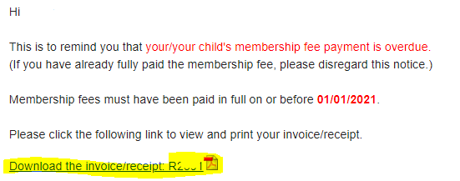
- Click on the link to view the invoice/receipt. If invoice/receipt won’t load please contact treasuerrockets@gmail.com to ask for an updated one to be sent.

- review the invoice noticing the following balance due as highlighted here
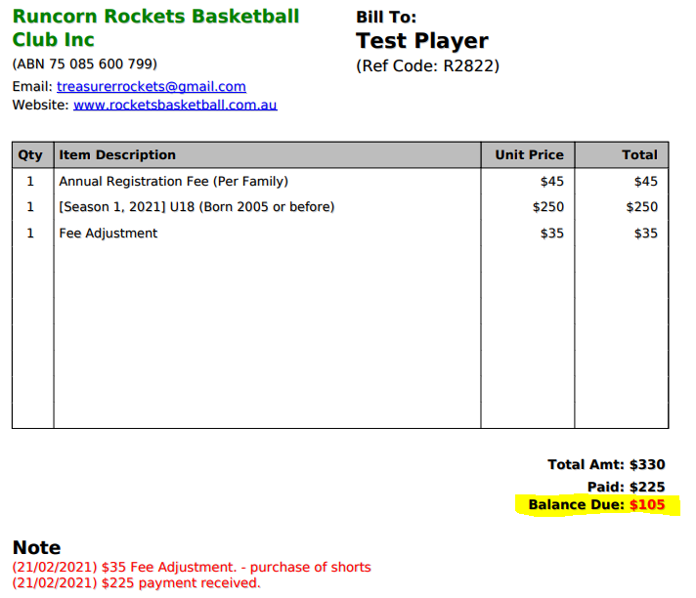

- Review the Notes which are highlighted below which show payments recorded and adjustment made for items like shorts or pack purchased.
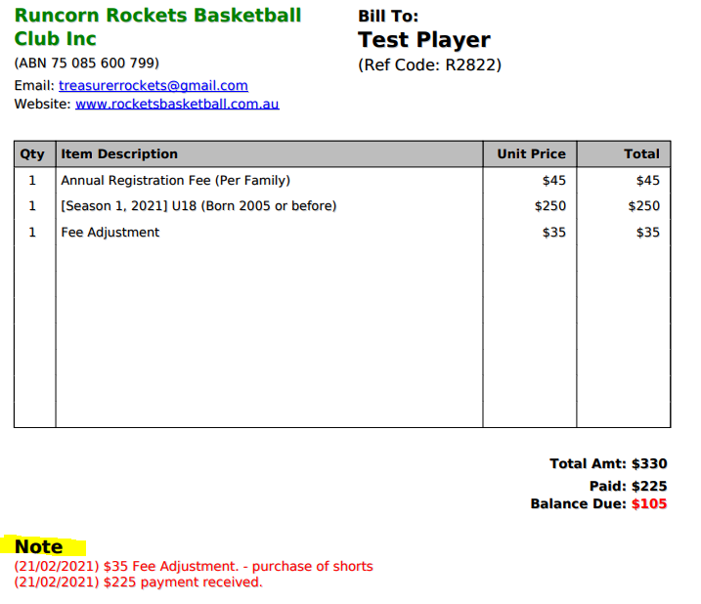

If any of this looks incorrect please contact Mike at treasuerrockets@gmail.com advising the error. Please provide details of the error and if it relates to a missed payment please advise date paid and amount. Note if you have made a payment in the last two business days and haven’t received an update email/invoice then please wait for this before contacting Mike. If no note is received after 2 business days from when payment was made then please contact Mike.
Please don’t ignore as no pay no play is now enforced. Where on a payment plan reminders will continue to be sent but can be ignored while active and confirmation has been received from treasurerrockets@gmail.com.
Please ensure the overdue amount is paid now or make contact with treasurerrockets@gmail.com to start a payment plan.

Any queries please email treasurerrockets@gmail.com

