Team App Instructions
For all

Team App download instructions
Install the Runcorn Rockets Basketball Club App on your smartphone or tablet now. Follow these steps:

Step 1 | Download Team App from the Apple or Google Play app store.
Step 2 | Sign up to Team App. You will be sent an email to confirm your registration.
Step 3 | Log into the App and search for "Runcorn Rockets Basketball Club" (shown below).  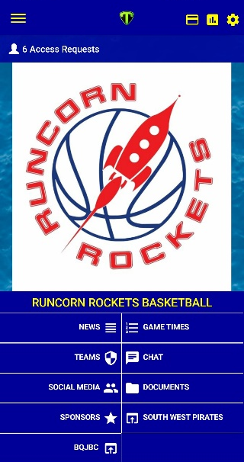  Click on Runcorn Rockets, your home screen should have a Runcorn Rockets icon and blue background (see picture on the right)
Step 4 | Looking for your teams/groups and access:  - Go to settings in our home screen  - Go to "Membership", under the "Membership" area you will see "Access Groups".  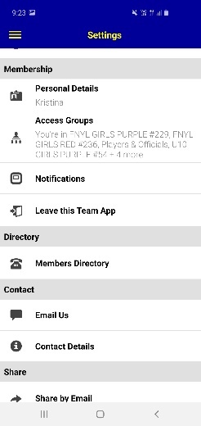  - Click on "Access Groups" then it should have a list of teams within Runcorn Rockets. Please select your team and fill out the relevant details (send, a message will be sent to admin).  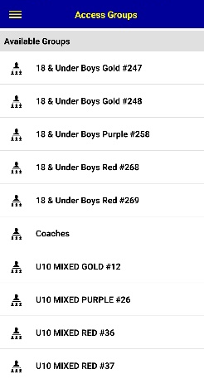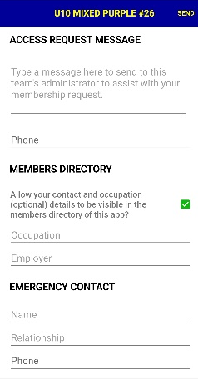  IMPORTANT NOTE: Please ensure that if you are requesting access for a child or another person, put that note within the "Access Request Message".
Step 4 | Ensure you have access to your team, by going back to your home screen click on Teams – find your team, click into the team and you should be able to see the details.

Team App - communications tool

This is the key way players & parents will access up to date information including:

  - News: key updates will be posted here
  - Events: any events that the committee are aware of will be posted here
  - Game times: links to SportsTg for fixtures, game times and locations
  - Ladders: links through to the ladder for each team
  - Team Selection: lists the players selected for each team
  - Chat: a place for team specific “chat” to occur
  - Social Media: links to facebook, twitter, website etc
  - Newsletters: copies of junior unit newsletters
  - Documents: links to key documents such as policies
  - Sponsors: information about the Club’s sponsors

If you or your coach do not appear to have access please email runcornrockets@gmail.com

Something not working? : go to the TeamApp FAQs section – link below https://www.teamapp.com/faqs

